GITLAB 2
Agenda
- Before Script and After Script
- Running Bash Script
- Job Artifacts
- Environment Variables
- Common Keywords
- Running Pipelines Manually
- Scheduling Jobs Using CRON Gitlab
- Manual Deployment
- Pre-defined Variables
Before Script and After Script:
In GitLab CI/CD, before_script and after_script are special keywords in the .gitlab-ci.yml file that define commands to run before or after each job in your pipeline.
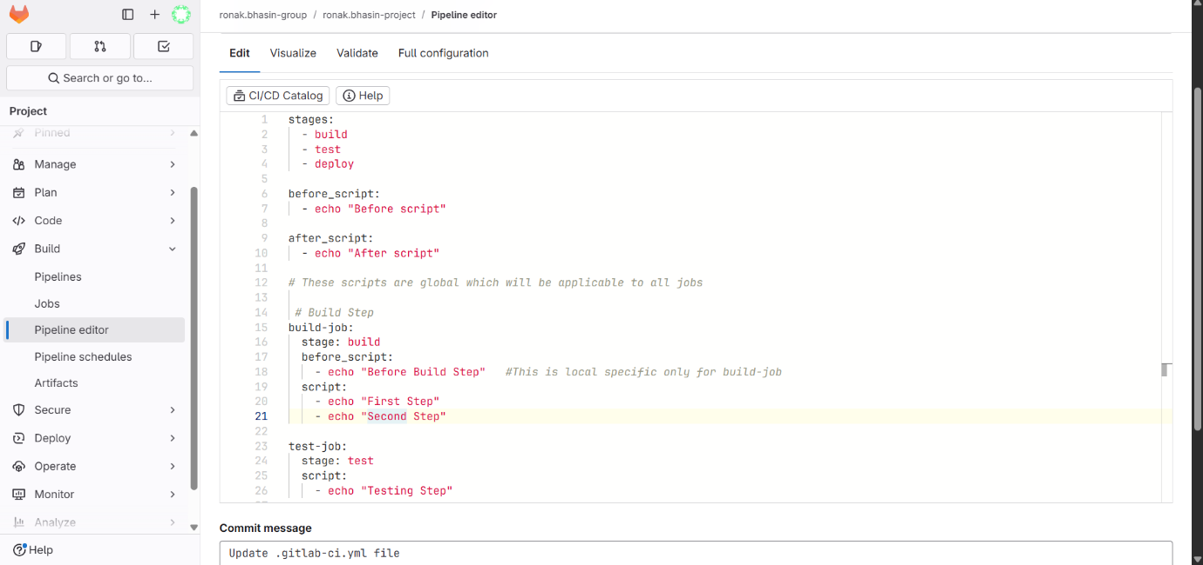
Now, the pipeline has passed.
To see the changes click on pipeline and open logs.
Here, you can see the changes of before and after script.
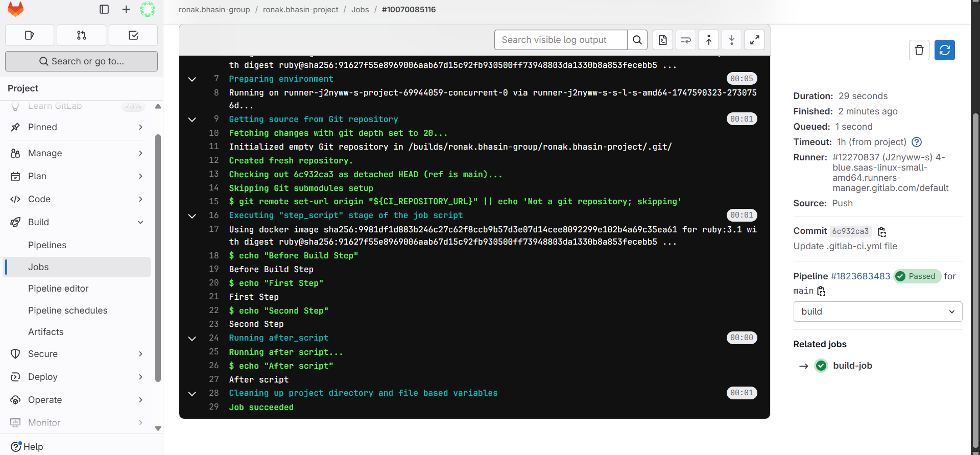
Running Bash Script:
Step 1: Create a file in the main project and add this code in the file.
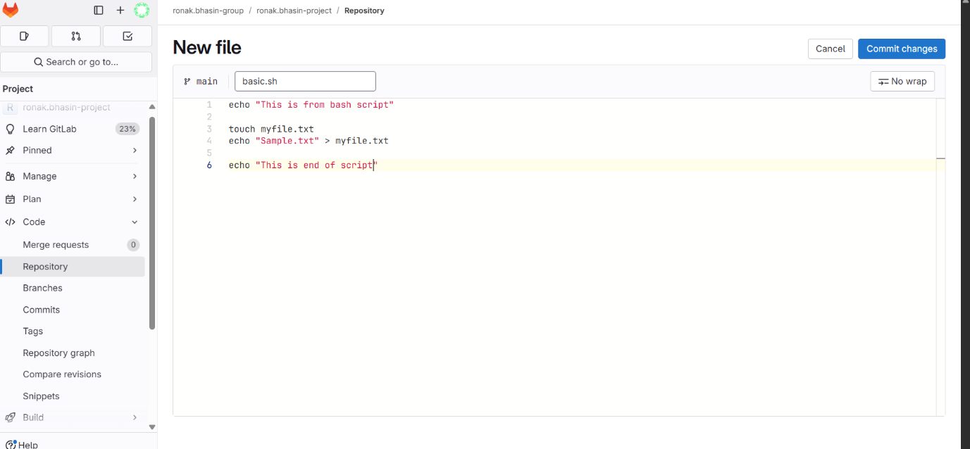
Step 2: Now, add by committing changes.
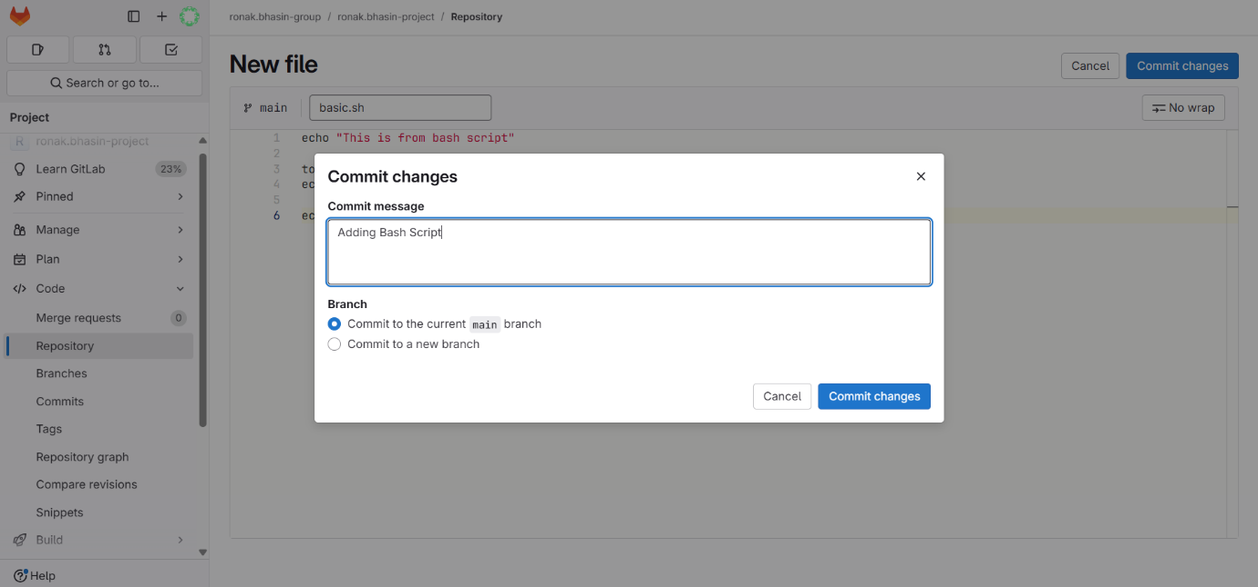
Now, you will see these two type of files in project, the difference between these 2 is:
1. .gitlab-ci.yml
- Type: GitLab CI/CD configuration file (YAML format)
- Purpose: Defines your pipeline, i.e., what jobs should run, in what order (build, test, deploy), and under what conditions.
- Runs: Automatically interpreted by GitLab Runner.
2. basic.sh
- Type: Bash script
- Purpose: A shell script you’ve written to run commands or perform tasks (e.g., build code, process data, deploy, etc.)
- Runs: Manually or as part of a pipeline (via a job in .gitlab-ci.yml).
Example content:#!/bin/bash
echo "This is a fundamental bash script"
Step 3: Now, to run this bash file, open the, ,gitlab-ci.yml file and to save processing time lets clear it and write new code for running our bash file created.
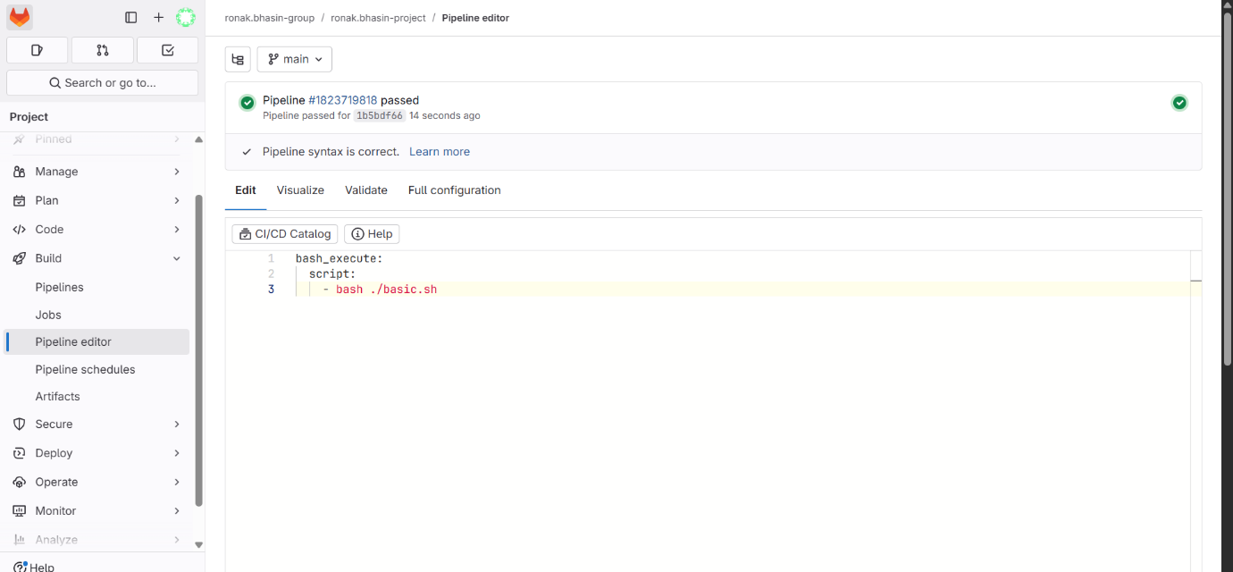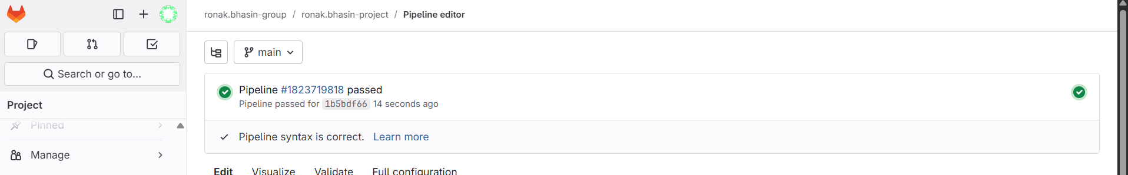
Step 4: Now, you can check the correct working by opening the log.
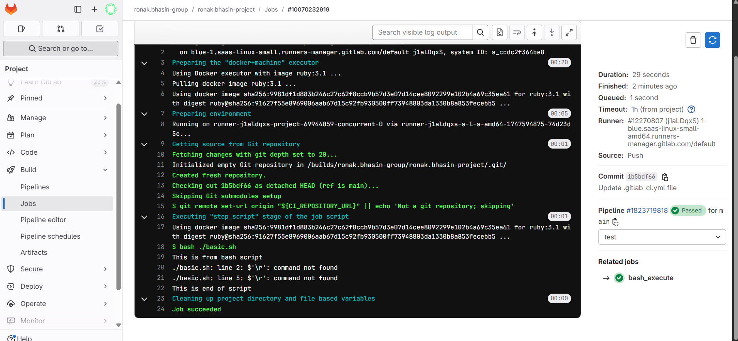
Now, the file created named myfile.txt is removed automatically after the job is completed, so for this you need to use Artifacts.
Job Artifacts:
Artifacts in GitLab CI/CD are files generated by jobs (e.g., build outputs, test results) that are saved and uploaded so they can be:
- Accessed after a job completes.
- Passed between jobs and stages in the pipeline.
- Downloaded manually from the GitLab web UI.
Common Use Cases:
- Sharing compiled binaries between stages (e.g., build → test).
- Storing logs, coverage reports, test reports.
- Archiving packaged applications (e.g., .zip, .jar).
- Debugging CI failures by preserving generated files.
Basic Structure in .gitlab-ci.yml:
job_name:
script:
- make build
artifacts:
paths:
- build/
Artifacts Keywords:
Here are all the commonly used subkeys under artifacts:
Key | Description
paths | List of file/folder paths to upload as artifacts
expire_in | How long the artifact is stored (default: 30 days)
when | When to upload the artifact (on_success, on_failure, always)
name | Custom name for the artifact (can include variables like $CI_JOB_NAME)
exclude | Files to exclude from paths
reports | Specifies structured data (e.g., test reports, code coverage, etc.)
untracked | If true, uploads all files not tracked by Git
This is how you will use artifacts to save data of the file by creating a folder named myfolder and inside it and save it.
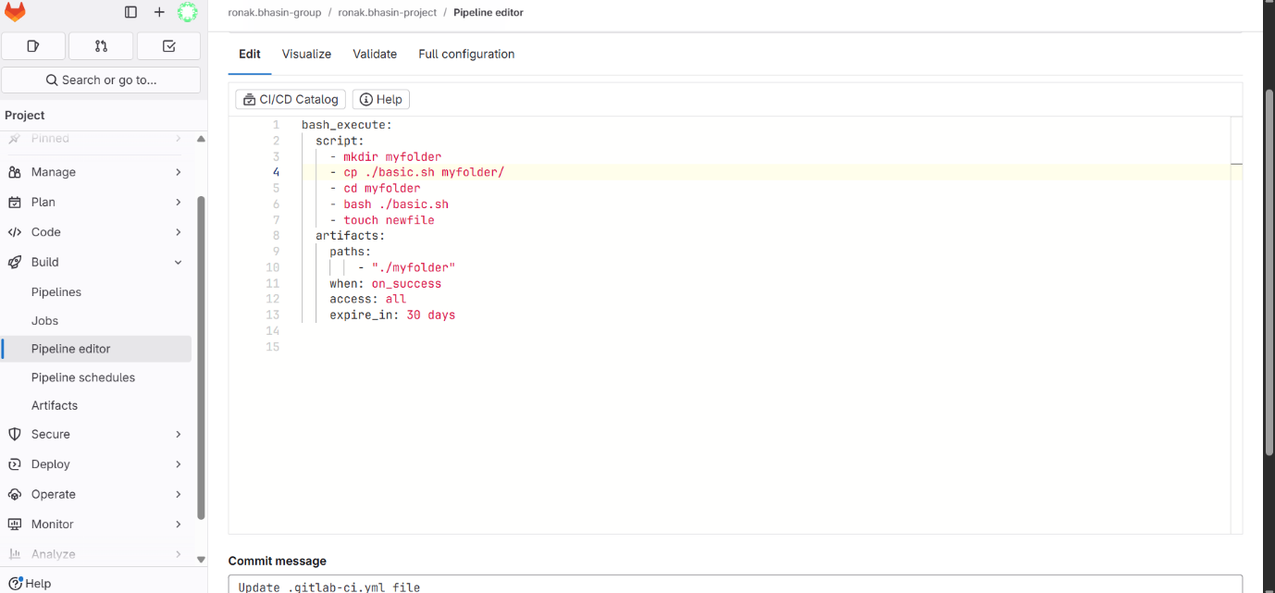
Code for reference:
bash_execute:
script:
- mkdir myfolder
- cp ./basic.sh myfolder/
- cd myfolder
- bash ./basic.sh
- touch newfile
artifacts:
paths:
- "./myfolder"
when: on_success
access: all
expire_in: 30 days
Now, you can check in logs after the pipeline has passed.
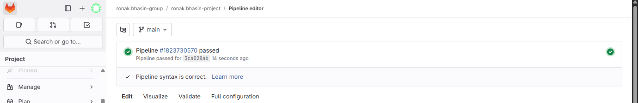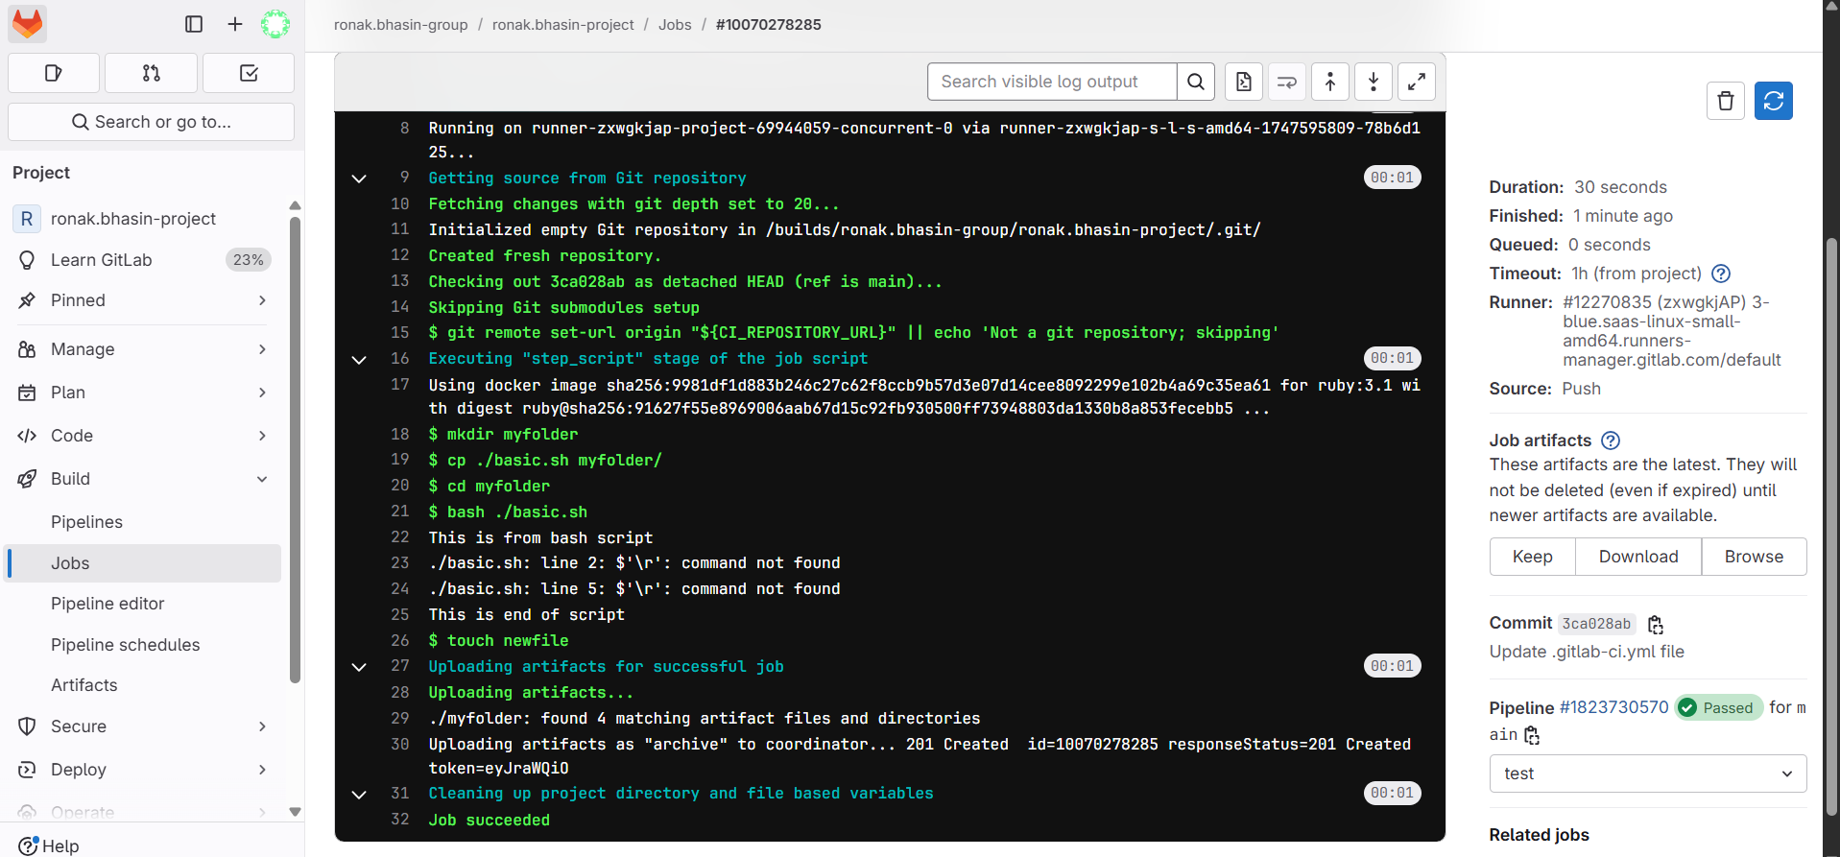
On the right hand side in the Jobs artifacts section, you see three options on clicking Download, you can download the zip file and if you click on Browse you will see the folder created like below.
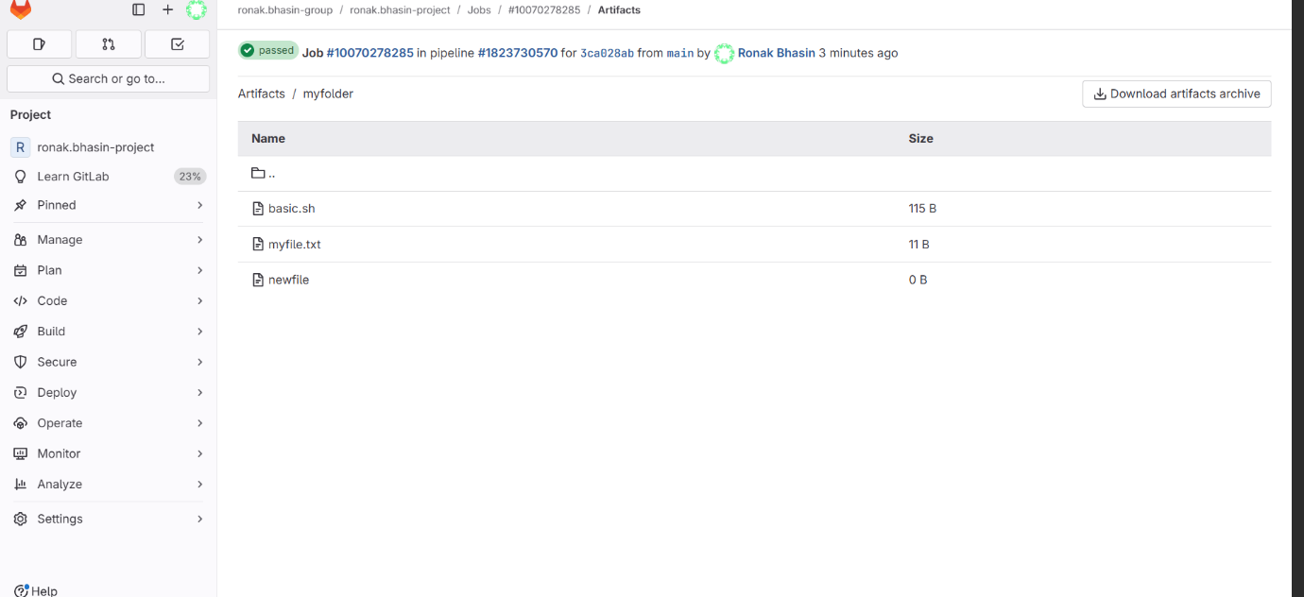
And on going to myfile.txt, you will see myfile.txt created and on downloading a notepad will be downloaded in which our data Sample.txt created has been stored and visible.
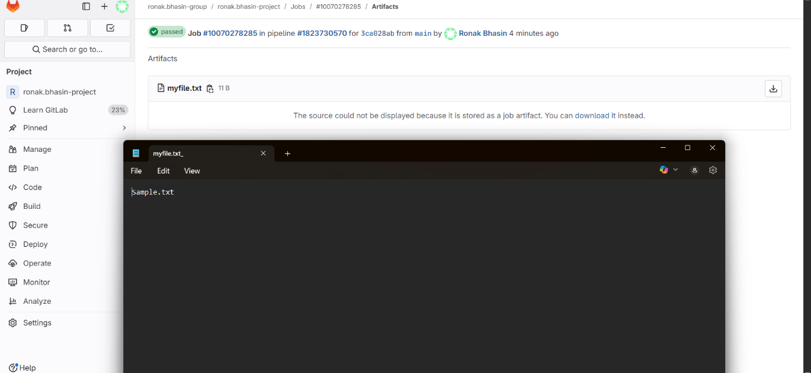
Environment Variables:
In GitLab, environment variables are used to store dynamic values or secrets (like API keys, credentials, configuration options) that can be accessed during CI/CD pipeline execution. These variables are defined in the GitLab CI/CD settings and can be used in the .gitlab-ci.yml file.
Types of Environment Variables in GitLab:
1. Predefined Variables GitLab provides many built-in variables automatically, such as:
- CI_COMMIT_SHA: The commit SHA for which project is built.
- CI_JOB_NAME: The name of the job.
- CI_PROJECT_NAME: The name of the project.
- CI_PIPELINE_ID: The unique ID of the current pipeline.
2. Custom Variables You can define your own variables:
- At project, group, or instance level.
- In the .gitlab-ci.yml file.
- In the GitLab UI under Settings > CI/CD > Variables.
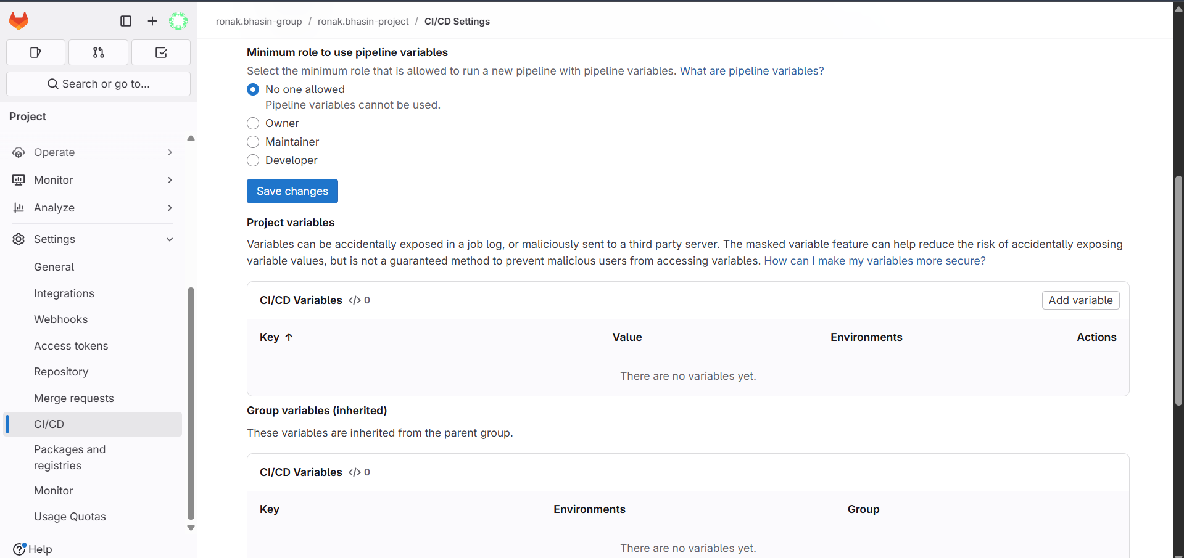
Using Variables in .gitlab-ci.yml:
variables:
APP_ENV: production
deploy_job:
script:
- echo "Deploying to $APP_ENV environment"
You can also reference predefined variables:
test_job:
script:
- echo "Running tests on branch $CI_COMMIT_REF_NAME"
Types of Custom Variables:
A. Secret Variables
To store secrets like API keys or passwords:
- Go to Project > Settings > CI/CD > Variables.
- Click "Add Variable".
- Set key-value pairs (e.g., AWS_SECRET_KEY, DB_PASSWORD).
- Set options:
  - Protected: Only available in protected branches or tags.
  - Masked: Hidden in job logs.
  - Environment scope: Limit to specific environments (like production, staging).
deploy_prod:
stage: deploy
only:
- main
script:
- echo "Deploying with key $PROD_DEPLOY_KEY"
PROD_DEPLOY_KEY would be added through the GitLab UI, not committed in code.
B. Temporary Variables in Jobs:
You can also declare variables in a job:
build:
script:
- MY_VAR="value"
- echo $MY_VAR
Note: These are only available in the current script.
Practical for addition of Environmental Variables:
Step 1: Go to the settings, under which go to CI/CD and select variables.
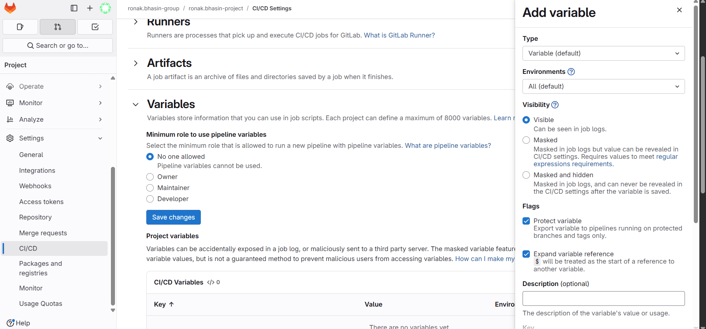
Step 2: Now, you will create 2 variables one Visible and other Masked.
A. Visible:
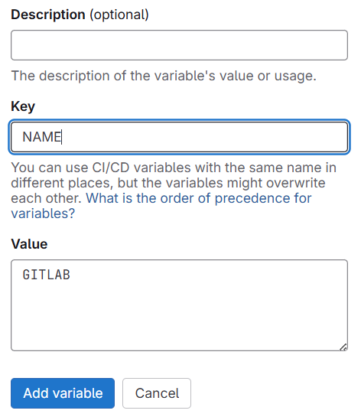
B. MASKED:
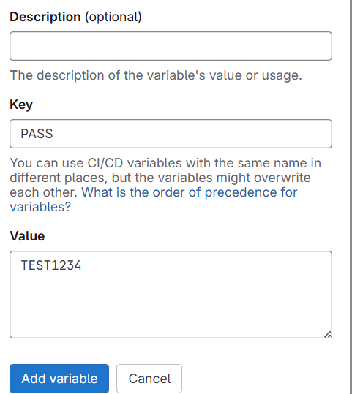
Step 3: Now, to use these variables, go to the repository and write this code.
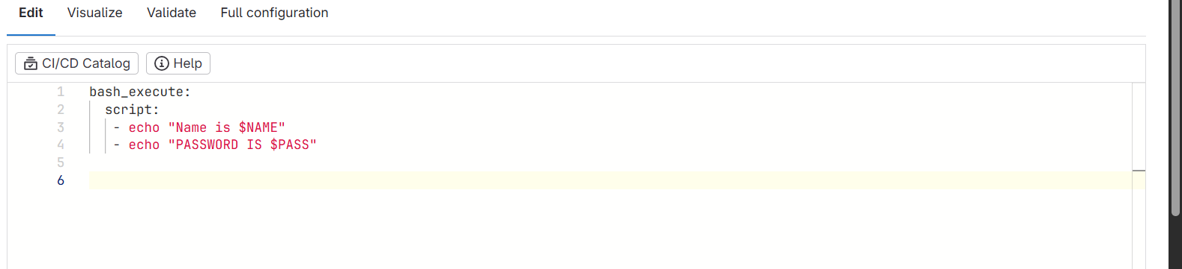
Step 4: Now, run this pipeline and check on the logs.
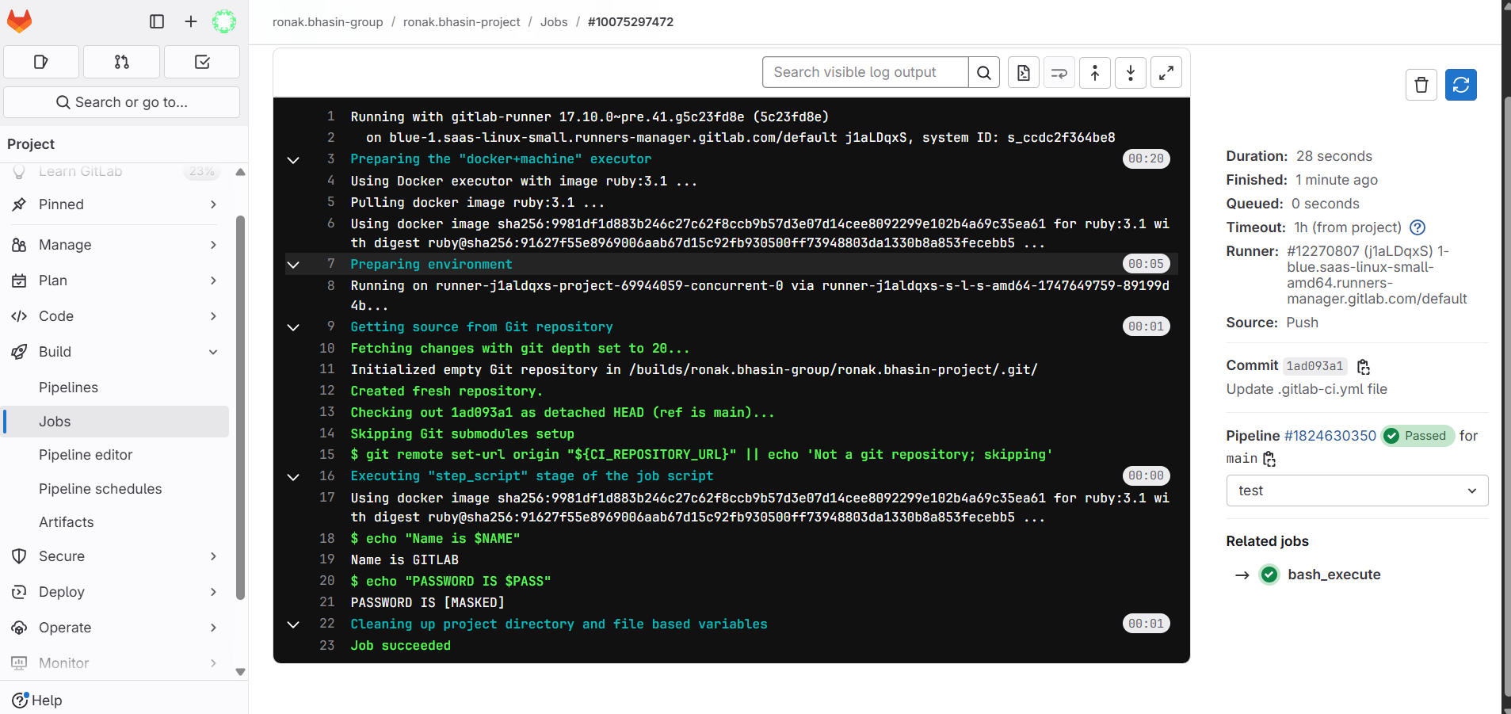
Common .gitlab-ci.yml Keywords:
These are the top-level or job-level keywords in GitLab CI/CD that control how pipelines behave.
Keyword | Description | Example
script | Commands to run in the job | script: - echo "Hello"
stages | Defines the stages of the pipeline | stages: [build, test, deploy]
stage | Assigns a job to a specific stage | stage: build
before_script | Runs before each job’s script | before_script: - setup.sh
after_script | Runs after the job’s script | after_script: - cleanup.sh
only / except | Controls when jobs run (deprecated) | only: main
rules | Advanced job conditions (preferred over only) | rules: - if: '$CI_COMMIT_BRANCH == "main"'
tags | Define runner tags for jobs | tags: [docker, linux]
image | Defines Docker image for the job | image: python:3.10
services | Docker services needed during job | services: - postgres:latest
variables | Define environment variables | variables: ENV=prod
artifacts | Save job output for later stages | artifacts: paths: [build/]
cache | Speeds up jobs by caching files | cache: paths: [node_modules/]
dependencies | Control which jobs must complete first | dependencies: [build-job]
needs | Define explicit job dependencies (parallel, DAG) | needs: [build, test]
environment | Set environment for deploy jobs | environment: production
when | Control job timing (e.g., manual, delayed) | when: manual
allow_failure | Allow job failure without failing pipeline | allow_failure: true
retry | Retry job if it fails | retry: 2
timeout | Limit job execution time | timeout: 10 minutes
extends | Reuse configuration templates | extends: .common-job
include | Import other CI files (modular pipelines) | include: 'ci/deploy.yml'
pages | Deploy static site using GitLab Pages | pages: block
Running Pipelines Manually:
Until now, pipelines were triggered automatically by editing and committing changes to the repository. However, if you want to run a pipeline manually without modifying or pushing any code, you can follow these steps, this approach is useful for:
- Testing pipeline changes without committing code
- Re-running failed jobs without code changes
- Manually triggering workflows like backups, reports, or deployments
Steps to Trigger a Manual Pipeline in GitLab:
Step 1: Navigate to your project in GitLab.
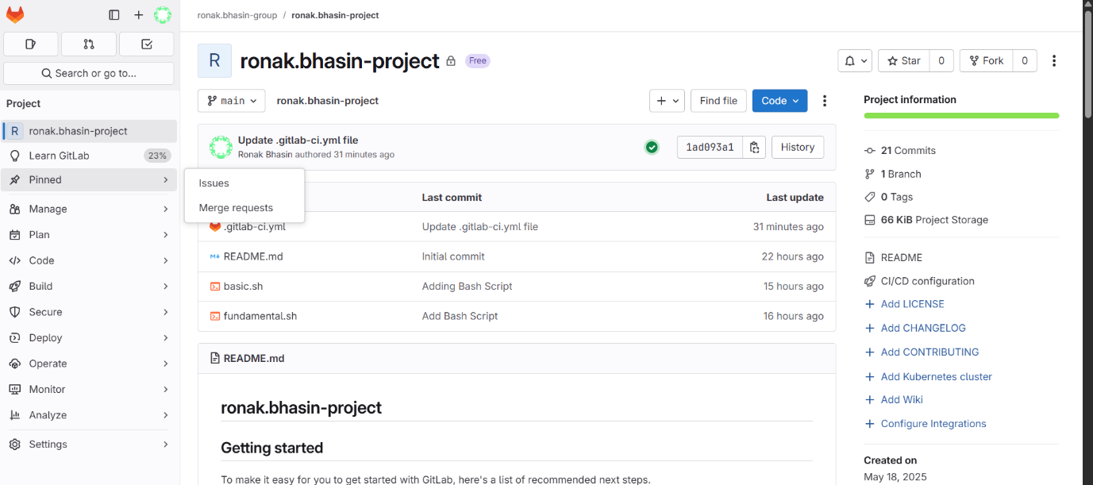
Step 2: Go to the Build option on the left side.
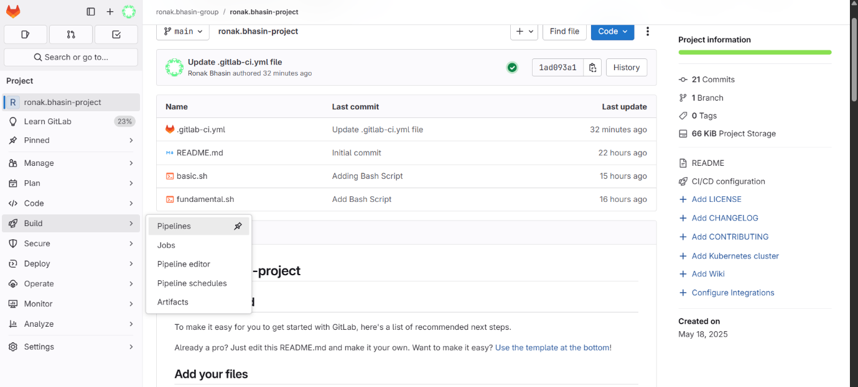
Step 3: Click the "New pipeline" button in the top-right corner.
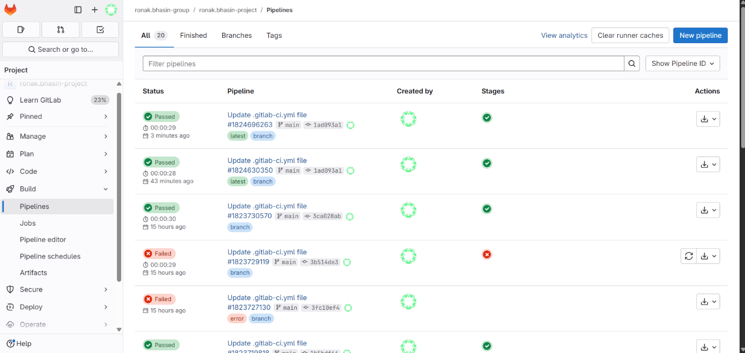
Step 4: Now, again click on New pipeline and this pipeline will start running.
NOTE: Since, this pipeline is same as what we created for environment variables, so there is no presence of INPUT.
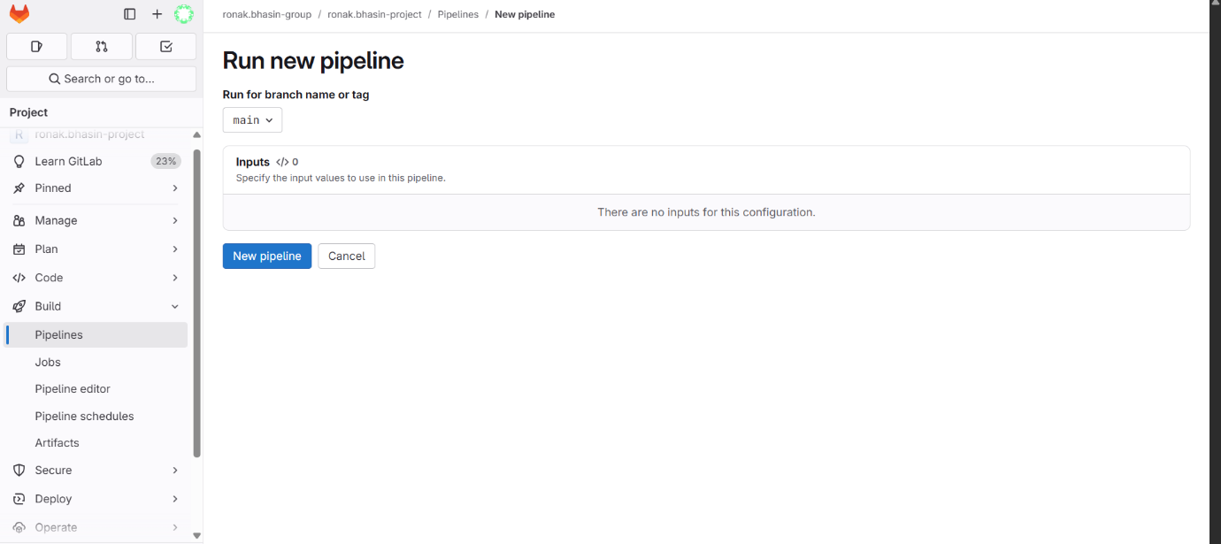
Step 5: Now, the pipeline is running
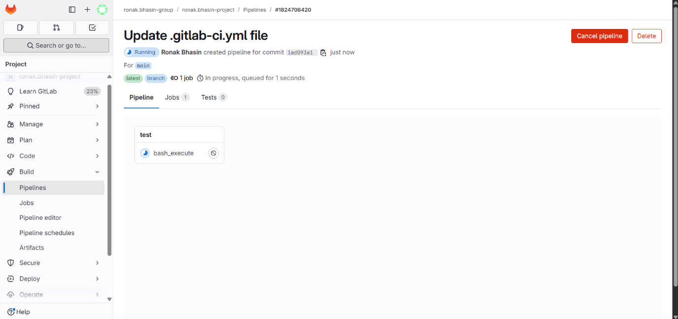
Scheduling Jobs using CRON Gitlab:
Job scheduling in GitLab allows you to automate the execution of CI/CD pipelines at defined intervals using CRON expressions. This enables jobs to run without requiring a code change or manual trigger.
GitLab provides this feature through Scheduled Pipelines, which execute according to the schedule you define.
Why Use Scheduled Jobs:
Scheduled jobs are useful for:
- Running nightly builds or tests
- Performing daily backups
- Syncing data at regular intervals
- Generating reports periodically
- Automating deployments during off-hours
- Monitoring or housekeeping tasks
How It Works:
- You define a schedule in the GitLab UI using a CRON expression.
- The pipeline runs automatically on the selected branch at the scheduled time.
- GitLab uses the latest code from that branch when the job runs.
Steps to Schedule a Pipeline in GitLab:
Step 1: Go to your GitLab Project.
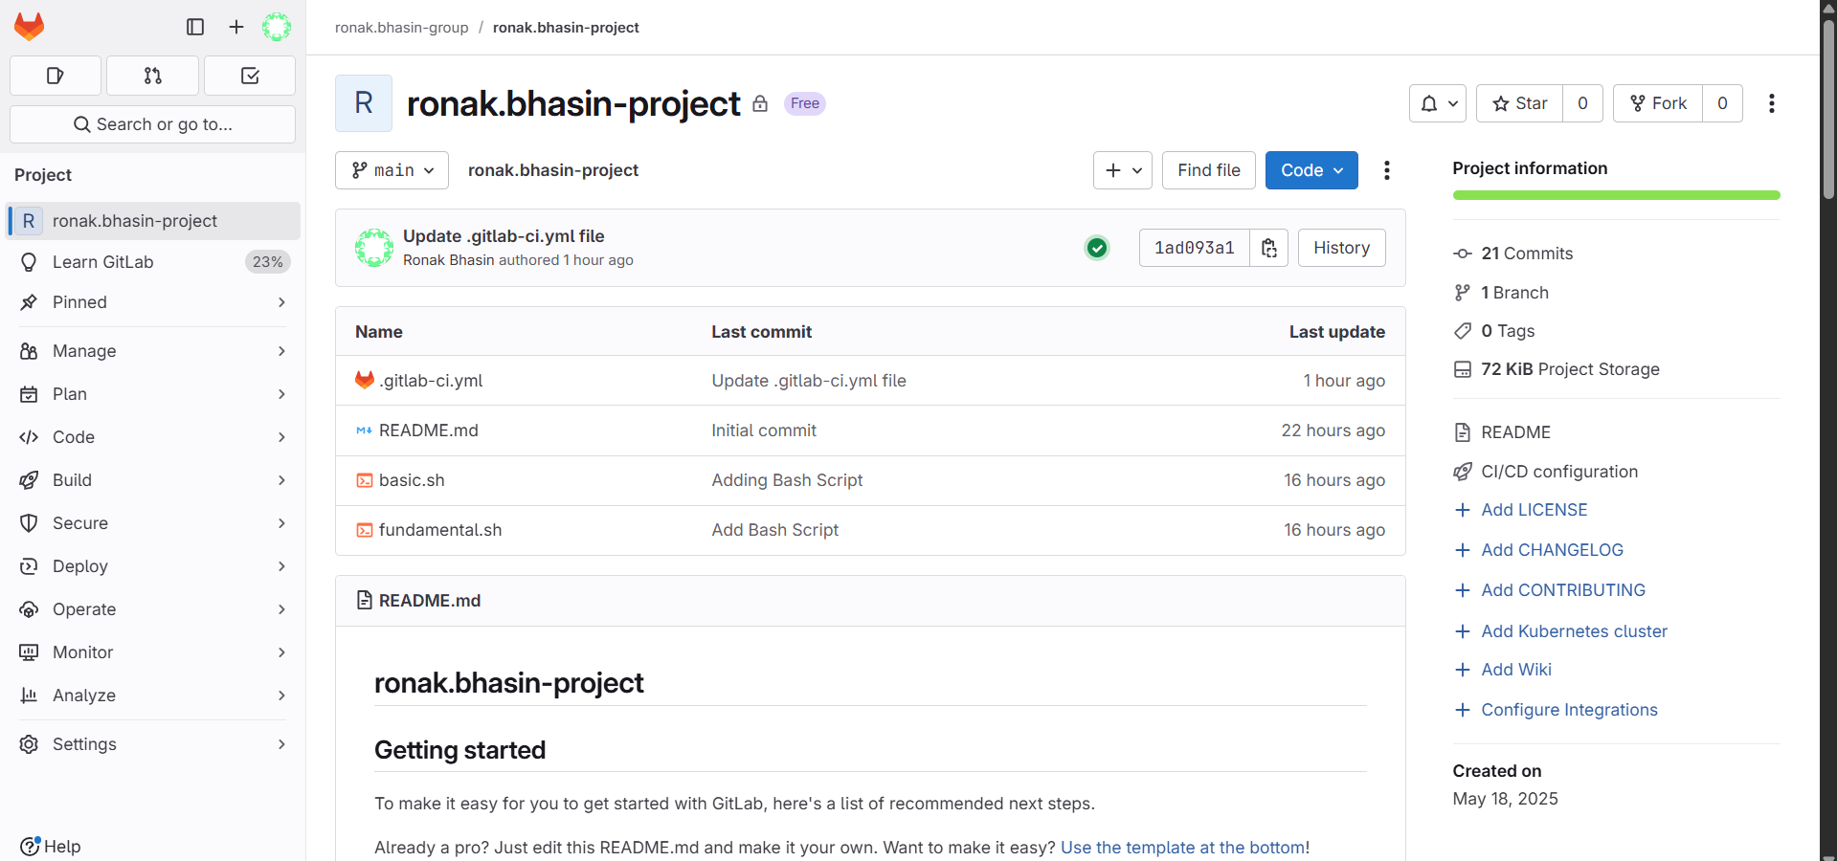
Step 2: Click on CI/CD > Schedules in the sidebar.
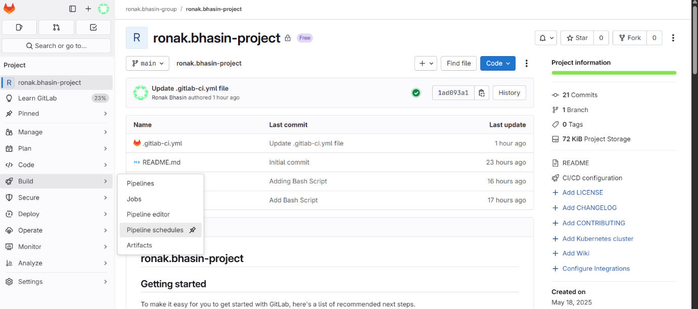
Step 3: Click on “Create a new pipeline schedule”.
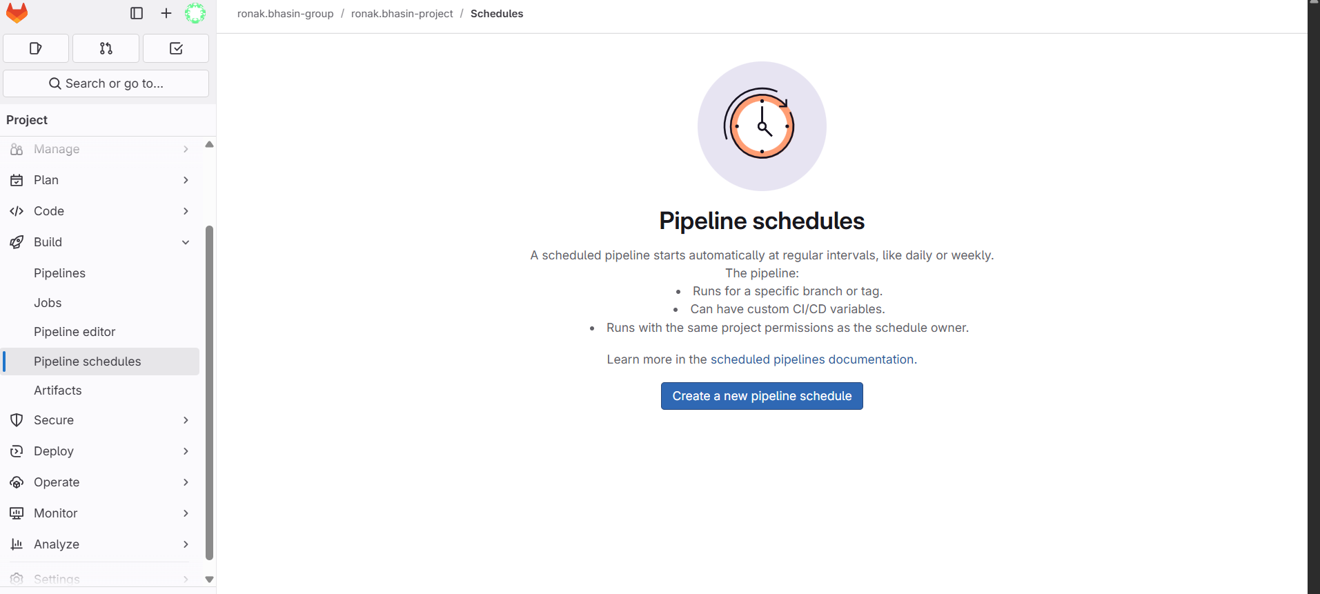
Step 4: Provide the following:
- Description (e.g., Nightly Build)
- Target branch (e.g., main)
- Interval pattern using CRON syntax
- Timezone
- (Optional) Define variables for the job
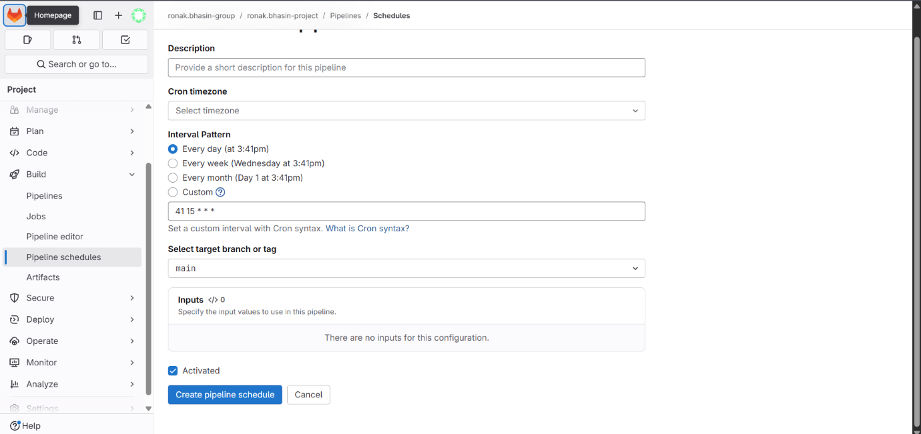
Step 5: Click Save pipeline schedule.
CRON Expression Syntax:
CRON expressions consist of 5 fields.
* * * * *
│ │ │ │ │
│ │ │ │ └─ Day of the week (0-6 or SUN-SAT)
│ │ │ └─── Month (1-12 or JAN-DEC)
│ │ └───── Day of the month (1-31)
│ └─────── Hour (0-23)
└───────── Minute (0-59)

Common CRON Examples:
CRON Expression | Schedule Description
0 * * * * | Every hour
0 0 * * * | Every day at midnight
30 9 * * 1-5 | Weekdays at 9:30 AM
*/15 * * * * | Every 15 minutes
0 0 1 * * | On the 1st day of every month
Best Practices:
- Use meaningful names/descriptions for schedules.
- Test your .gitlab-ci.yml manually before scheduling.
- Use environment variables to differentiate scheduled jobs.
- Monitor pipeline logs to ensure the job runs as expected.
Manual Deployment:
Manual deployment refers to the process where deployments are intentionally triggered by a user, rather than happening automatically as part of a continuous deployment process. This provides greater control over when and how code changes are pushed to different environments (e.g., staging, production).
When to Use Manual Deployment:
Manual deployments are typically used in scenarios like:
- Releasing to production after thorough testing
- Deploying to staging for QA approval
- Ensuring a controlled rollout of sensitive changes
- Coordinating deployment with business or downtime windows
- Avoiding automatic deploys during non-working hours
Manual Deployment in GitLab:
In GitLab, manual deployment is achieved using the when: manual keyword in the .gitlab-ci.yml file.
Example:
deploy_production:
stage: deploy
script:
- ./deploy.sh
when: manual
only:
- main
This configuration means:
- The job runs only on the main branch
- It will not run automatically; instead, a user must click "Play" in the GitLab UI to trigger it
How to Trigger a Manual Deployment in GitLab:
Step 1: Go to your project in GitLab.
Step 2: Navigate to CI/CD > Pipelines.
Step 3: Find the latest pipeline run.
Step 4: Locate the job labeled with a “Play” button.
Step 5: Click “Play” to trigger the manual job.
Pre-defined Variables:
Predefined variables in GitLab are automatically created and populated by GitLab during CI/CD pipeline execution. These variables contain important information about:
- The pipeline
- The job
- The Git repository
- The runner
- The environment
You can use them in your .gitlab-ci.yml file, scripts, and jobs to dynamically control behavior.
Example Usage in .gitlab-ci.yml:
build-job:
script:
- echo "Running job on branch: $CI_COMMIT_BRANCH"
- echo "Project: $CI_PROJECT_NAME"
- echo "Commit SHA: $CI_COMMIT_SHA"
Go through this docs for seeing the list of pre-defined variables.

